HAC Amateur Photography Competition

SATURDAY, January 25, 2025, 3-5pm

Adult and Children’s Division MUST HAVE AN 8X10 OR LARGER PHOTO IMAGE, FRAMED AND WIRED ON BACK FOR HANGING. A total of five (5) photos may be entered in a choice of five categories - no limit per category. For each work entered you must fill out an identification tag and attach it to the back of each entry. Entries are to be dropped off at the Cultural Center with the entry card filled out. Entry fee is $5 per photo.
Entries and Fees must be received on Thursday, January 16th or Friday, January 17th, 2025 from 11am – 6pm

DELIVER PRINTS TO:
Hattiesburg Cultural Center, 2nd Floor
723 North Main Street
Hattiesburg, MS. 39401

ENTRY CARD

Name: _________________________________________________________________________
Address: ________________________________________________________________________
Email: _________________________________________________________________________
Phone: ____________________________ Division: (Circle One) Adult Children

Title Category Price/Value
1. _______________________________________________________________________
2. _______________________________________________________________________
3. _______________________________________________________________________
4. _______________________________________________________________________
5. _______________________________________________________________________

The rule of “good taste for the viewing public” will be at the discretion of the jurors and the decision of the jurors is final.

CERTIFICATION:
This print is original and was made by me or under my direct supervision.

Signature____________________________________________________________

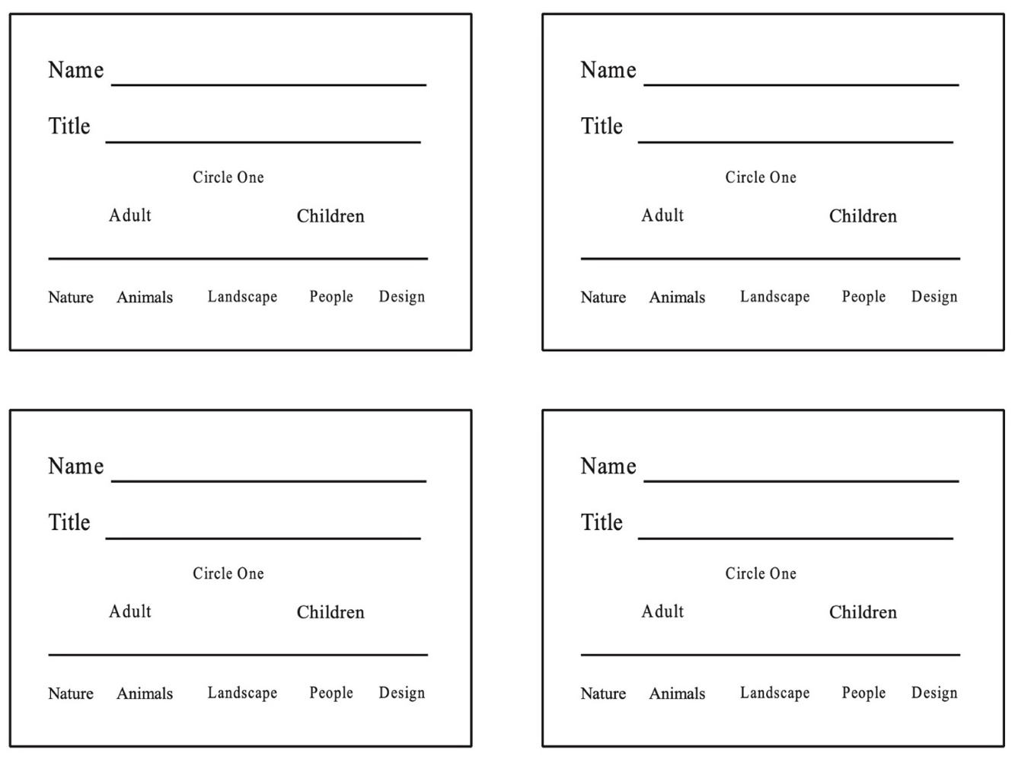
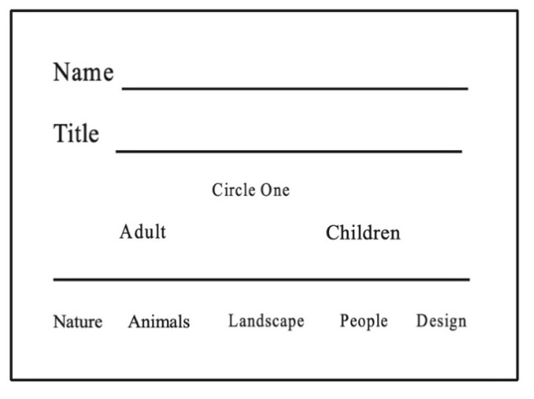

The utmost care in handling will be given to all entries. However, the Hattiesburg Arts Council cannot assume responsibility for any damages incurred before, during or after exhibition or for damage or loss during transit.

